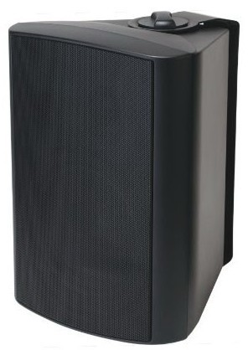
6" Two Way Wall Mount Speaker (40W)
FWS-440
Feature:
- Commercial PA system wall mount speaker with transformer
- Ideal for school, office, hotel and airport background music system
- Economy rang fashion wall mount cabinet loudspeaker
- Rated power output 40W at 100V
- 6" woofer and 1.5” tweeter two way speaker units
- Line input 100V or 70V
- ABS enclosure, metal grille in black
- Quick installation by supplied stainless mounting bracket
- FWS-440W as option of white finish
Specification:
Model | FWS-440
Description | 6” Two Way Wall Mount Speaker
Rated Power Output | 40W
Line Input | 100V or 70V
Frequency Response | 100-20KHz
SPL(@1W/m) | 96dB
Speaker Unit | 6” woofer and 1.5” tweeter two way speaker units
Dimension | 215(W)×190(D)×285(H)mm
Material | ABS enclosure and metal grille in black
Mounting Way | Quick installation by supplied stainless mounting bracket
Weight | 3.5kg
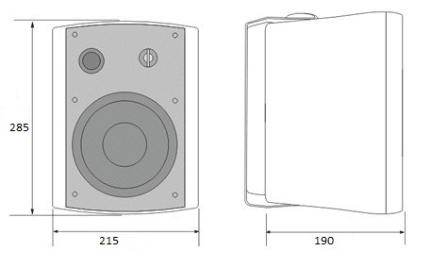
Side View & Dimensions:

Frequency Response VS SPL Diagrams:
