PA Amplifier with ECHO/USB/SD & FM & Blue Tooth, DC12V
FA-30MD/FA-60MD

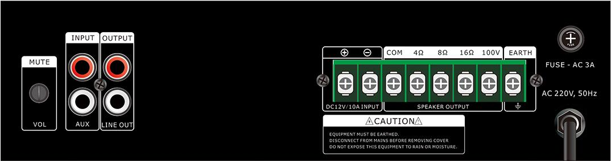
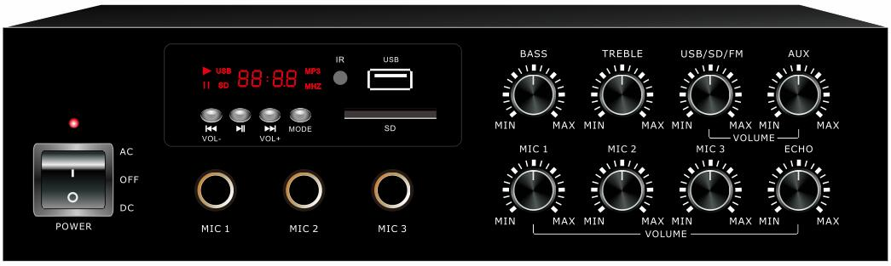

Features:
- Compact mini size public address amplifier
- Ideal for classroom sound system use
- Built-in 100V/70V transformer technology
- Tabletop amplifier with Mp3 player, FM radio & blue tooth
- Rate power output at 30W to 60W . Speaker output of 100V or 70V & 4Ohms-8 Ohms-16 Ohms
- Mp3 player with USB/SD input on front panel, IR remote control for Mp3 player, FM radio and blue tooth
- LED indicators for power, clip, protect and signal
- Mic1-3 and one line. Mic1 of highest priority and one RCA line input and one RCA line output
- Volume control for Mic1-3, line1 and ECHO, Mp3/FM, bass/treble and master
- With short-circuit, clip, overload and high temp protection
- AC220V or 115V & 12V DC both operation system

Specification:

Model | FA-30MD  FA-120C  FA-240C | FA-60MD  FA-500C
Description | Public Address System 30W Mixer Amplifier
Rated Power Output | 30W  120w  240w | 60w  500w
Speaker Output | 70V, 100V and 4-16Ω
Input | Mic1-3: 600 ohms(Ω) 5-8 mV, unbalanced, Line1: 10k ohms(Ω) 150-470 mV,  unbalanced
Frequency Response | 60-15KHz
THD | <0.5% at 1kHz, 1/3 rated power
S/N Ratio | Line: 85 dB , MIC: >72 dB
Protection | High temp, short circuit, overload protection
Power Supply | AC230V or DC12V, 50-60Hz
Power Consumption | 50W  150W  310W | 80W  650W
Dimension | 253(W)×220(D)×68(H)mm
Gross Weight | 4.2kg  6.6kg  9.6kg | 5.3kg  13.7kg
Warranty | 3 years

